**EBS vs EFS:**

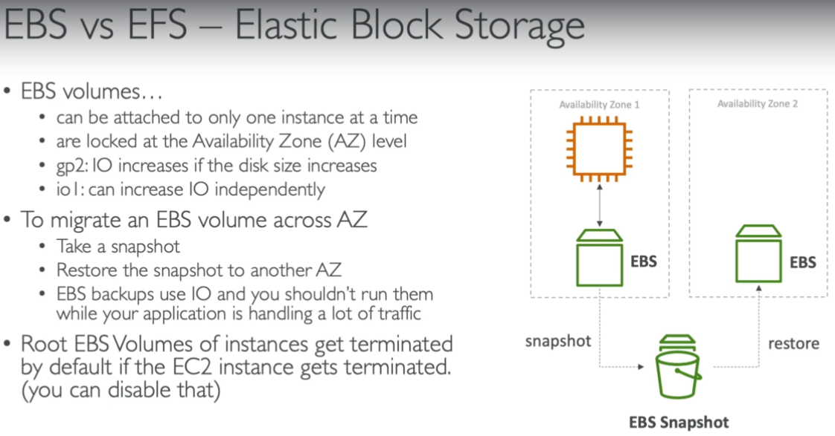

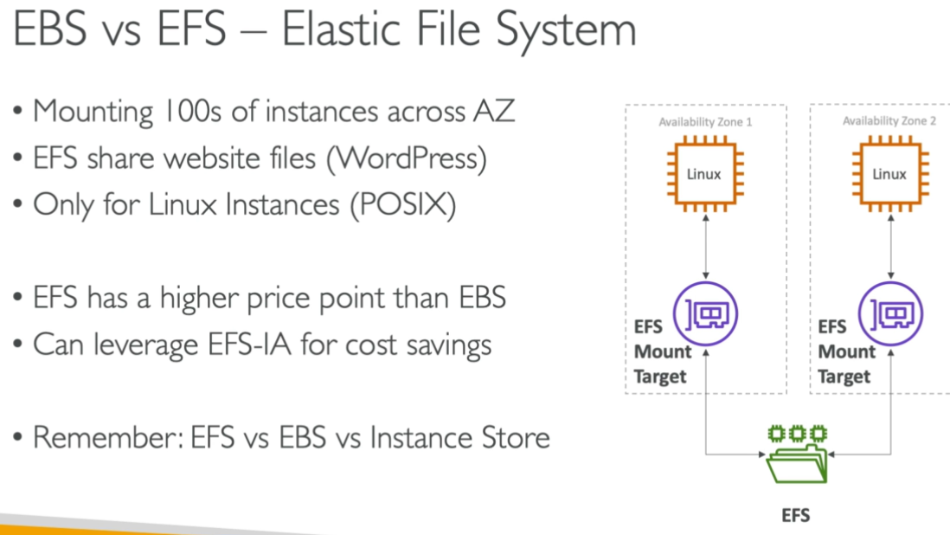

**EFS charges will be based on the usage on data we store in file system.**